Sui Foundation Research Awards Proposal 2024

- Introduction

Prospective users are interested by the features of Web3, but are rightfully worried about custody of their secret keys. Web3 platforms provide users with unprecedented levels of control over their digital life, but this control hinges on users keeping secure custody over their private keys. The compromise of cryptographic key material is the most catastrophic loss a user can experience, resulting in funds being drained or smart contracts being hijacked.

Existing key custody solutions consist of tradeoffs between convenience and cost. Many people are onboarded to their Web3 journey with a smartphone wallet. The ease and convenience of smartphones, however, comes with the risk of accidental device loss. Moreover, illegal actors and rogue governments alike can easily bypass smartphone security mechanisms to recover secrets. Common approaches in the cryptocurrency community include using a hardware wallet or paying for third-party key escrow, but both require upfront costs. These costs turn away those who are curious, but not fully committed.

I propose at-home key custody, the re-use of the user’s existing devices to provide Web3 key custody. Users increasingly have IoT devices, which have low specifications and are application-specific. An individual IoT device is a single point of failure, like a smartphone; a smart home of several devices, however, can provide security in numbers. Suppose a user has a smart home of IoT devices fixed-in-place (e.g., smart thermostat, smart lightswitch, smart fridge, etc.). If the smart home, collectively, could hold the user’s key, and sign transactions on behalf of a user, then the user has bound their Web3 and dApp access to their home.​​ Then, users would onboard onto the Web3 platform using their home as their key custodian. Security would hold because the key material on the IoT devices does not leave the home -- an adversary who compromises a smartphone alone cannot sign transactions on behalf of its user.

My recently published work provides evidence that tying cryptographic operations to the devices of a smart home is a feasible approach. In this work, SocIoTy, we develop a system that builds symmetric authentication from a smart home to provide two-factor authentication. The IoT devices located in the smart home, along with the user’s smartphone, engage in a lightweight protocol to compute two-factor authentication codes. The smart home, in effect, becomes the authentication factor -- somewhere you are, in addition to the traditional triad of something you know, something you have, and someone you are.

Preliminary data from my initial work shows that even microcontroller-class IoT devices are fast enough for cryptographic protocols. We ran our Rust implementation on different classes of devices, like Raspberry Pi Zeros (similar hardware to a smart thermostat) and ESP32 microcontrollers (similar to a smart lightswitch). As a part of our protocol, these devices calculate one elliptic curve operation, which is very efficient: 0.0029 seconds on RPi Zero, and 0.04368 seconds on ESP32. We also evaluated the entire system end-to-end, generating codes with a smart home network of several IoT devices and displaying them in an iOS app. The figure to the right depicts our results. Depending on the number of devices t required to compute a two-factor authentication code, execution end-to-end takes only between 0.2 and 0.5 seconds, on average, meaning distributed protocols can scale well even on these devices.

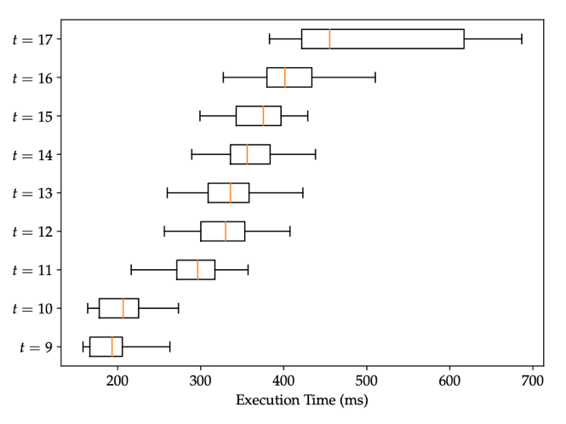
My prior work shows the promise of at-home cryptography, but research questions remain in developing at-home key custody for Web3 platforms. Web3 requires the use of asymmetric cryptography (i.e., digital signatures), which is more heavyweight than the symmetric primitives used in SocIoTy. More generally, the efficiency of current distributed signing protocols on IoT devices is not well understood. Additionally, SocIoTy does not handle churn; users purchase and sell IoT devices regularly, so we must consider how to perform secure setup and decommissioning of existing key material. These questions must be addressed to achieve practical deployment of smart home-based key custody.
- Methodology

First, I will experimentally determine the limitations of at-home key custody by evaluating existing signing protocols. We require a threshold, distributed signing scheme to share key material in the smart home, but most current protocols were designed for general-purpose computers. So, we must determine the bottlenecks of current protocols on resource-constrained devices to identify improvements. I will work with an undergraduate research assistant to implement protocols from the literature on IoT devices and evaluate them on IoT hardware. We will focus this study on protocols for Ed25519 and ECDSA, since they are used in Web3 platforms such as Sui, and my prior results show that elliptic curve operations are efficient on IoT devices, even when multiple devices are involved.

Then, I will build out a new signing protocol that is tailored for IoT hardware while supporting device churn. To accomplish this, I will collaborate with Prof. Rosario Gennaro, an expert on cryptography and network security. Prof. Gennaro has performed foundational work on threshold signatures, as well as more recent work on fast threshold ECDSA with trustless setup suitable for cryptocurrencies. Using the insights from my initial experiments and his prior work on the topic, we will create a distributed signing protocol for IoT devices that both uses lightweight primitives and avoids re-sharing when devices enter and leave the smart home.

Finally, I will create an end-to-end deployment of the proposed key custody protocol on a smart home network of representative devices. I will work with the undergraduate research assistant to set up several smart home-class devices in a lab space. We will run our new protocol on these devices to sign user transactions destined for the Sui DevNet, evaluating our solution on a modern Web3 platform. This evaluation will reveal not just performance, but also usability and integration with real-world systems.

- Relevance to Sui Foundation objectives and themes

The core mission of the Sui Foundation is to onboard the next billion users of Web3. Sui’s innovations from protocol to platform to wallet all reflect this goal. The insight underpinning these innovations is simple: to onboard the next billion users of Web3, we need to meet users where they are, rather than where we need them to be. Sui’s zkLogin technology for seamless user onboarding via OAuth providers is a clear example of this maxim -- users already use online accounts, so re-use them. Like zkLogin, the proposed research allows prospective users to immediately onboard and experience Web3 technologies without worrying about key custody. Rather than re-using existing authentication systems (OAuth), however, this research re-uses existing hardware systems (IoT devices). So, this research augments and compliments the zkLogin technology, giving new users of dApps and Web3 the option of basing their key custody on OAuth, or through their smart home devices, depending on their level of comfort.

- Expected outputs

This project is estimated to take one year, after which two outputs will be available:
The Rust implementation and benchmarks of our proposed protocol will be posted on GitHub. The community can use our reference implementation to run our protocols on their own devices, and reproduce our results. Moreover, through the SPLICE group, I have connections with several IoT industry advisors, who are from companies like Amazon, Intel, and Samsung, and with whom I have successfully engaged in the past. I will leverage these contacts to transfer this research to industry for deployment on production devices.
A manuscript of the project’s design and results will be uploaded as a preprint. This effort will yield research contributions in both applied cryptography and distributed systems. I will therefore pursue publication of the manuscript in an academic venue after project completion.

